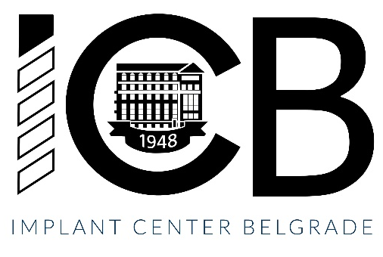
The One-year Implant Program in English

Venue: Implant Center Belgrade
Start date: October 15, 2026
The program is organized for 4 participants in English

Candidates can apply from May 8 to May 29, 2026, 10,00-13,00 at the Department of Teaching, Office for Postgraduate Studies, 8 Dr. Subotića St. or online by completing a submition form.
The program in English:
The price of this educational program in English is 20,000 euros in dinar equivalent (to be paid in 4 equal installments).
Candidates eligible for the educational program in English (foreign citizens) must have three years of clinical experience as a Doctor of Dental Medicine (certificate to be enclosed with application) or a specialization in one of the following fields: Oral Surgery, Periodontology and Oral Medicine, Maxillofacial Surgery, or Dental Prosthodontics (copy of specialist degree to be enclosed with application), as well as a certificate of English language qualifications.
If the candidate completed his studies in English, or comes from a country where English is the official language, this certificate is not necessary.
Candidates must submit a medical certificate and test results for specific diseases (HIV, Hepatitis B and C) during september 2025, before starting the program.
During enrollment, all participants will receive a certificate of attendance at the educational program for the purposes of obtaining a visa (if necessary) and regulating residence in the Republic of Serbia (mandatory).
Additional information can be obtained via: ana.sinobad.radulovic@stomf.bg.ac.rs

The One-year Implant Program
Head of the educational program: Prof. Aleksa Marković

The one-year implant program aims to provide participants with theoretical and practical knowledge and skills in Oral Implantology.

At the end of the one-year program, the program participants are expected to be competent at comprehensive treatment planning, implementation of surgical and prosthetic procedures of implant treatment from straight-forward to complex-advanced cases, the use of bone and soft tissue augmentation procedures, rehabilitation of edentulous patients, application of digital technologies in Implantology, as well as the management of peri-implant complications. The program will contain a relevant didactic theoretical part, hands-on workshops, live operations, mentored live patient treatment, seminars, and tests, as well as presentations of completed patient cases of program participants.
Upon completion, participants will receive a Certificate of Completion of the educational program.

The program is designed through six modules:
Module 1
Implant treatment planning and basic surgical principles
• Basics of Oral Implantology
• Diagnostics and treatment planning
• Virtual planning of implant placement and surgical guide fabrication for implant placement in CoDiagnostix ®software)
• Basic surgical principles for dental implant placement
Module 2
Prosthetic reconstruction on implants
• Planning of prosthetically guided implant placement
• Selection of materials in implant prosthetics
• Principles of occlusion in implant-prosthetics
• Steps for making individualized single crown restorations and bridges on implants
• Aesthetic principles of implant-supported restorations
Module 3:
Advanced augmentation procedures in Implantology
• Surgical principles of implant therapy in complex cases and bone atrophies
• Basics of bone regeneration
• Horizontal and vertical augmentation procedures in implantology
Module 4:
Rehabilitation of edentulous patients
• Diagnostics and treatment plan for edentulous patients
• Surgical procedures of implant placement in edentulous patients
• Prosthetic procedures for removable restorations in edentulous patients
• Prosthetic procedures for fixed restorations in edentulous patients
Module 5
Digital technologies
• Possibilities of applying digital technologies in Implantology
• Planning and fabrication of surgical guides for computer-guided installation of implant placement
• Digital laboratory procedures
Module 6
Patient maintenance and complications management
• Follow-up and maintenance phase in patients with implant-supported restorations
• Peri-implant diseases: prevention, diagnosis and treatment
• Management of soft tissues around implants
Dean
Prof. Vojkan Lazić

___________________________

