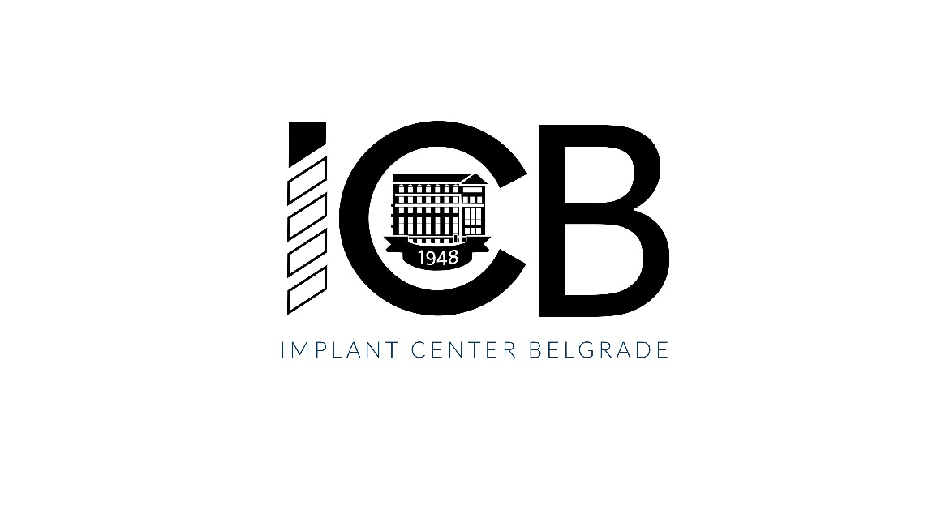**The One-year Implant Program in English**

**Venue: Implant Center Belgrade**

**Start date: October 15, 2025**

**The program is organized for 5 participants in English**

**Candidates can apply from May 5 to May 30, 2025, 9,00-13,00** at the Department of Teaching, Office for Postgraduate Studies, 8 Dr. Subotića St. or online by completing a [submition form](https://forms.gle/AV3U8Gx6JdjCjV2k6).

**The program in English:**

The price of this educational program in English is 20,000 euros in dinar equivalent (to be paid upon enrollment).

Candidates eligible for the educational program in English (foreign citizens) must have three years of clinical experience as a Doctor of Dental Medicine (certificate to be enclosed with application) or a specialization in one of the following fields: Oral Surgery, Periodontology and Oral Medicine, Maxillofacial Surgery, or Dental Prosthodontics (copy of specialist degree to be enclosed with application), as well as a certificate of English language qualifications.

If the candidate completed his studies in English, or comes from a country where English is the official language, this certificate is not necessary.

In May 2025, candidates will receive instructions for online payment of the educational program by e-mail.

Candidates must submit a medical certificate and test results for specific diseases (HIV, Hepatitis B and C) during september 2025, before starting the program.

During enrollment (September 2025, Office for Postgraduate Studies, 8 Dr. Subotića St.), all participants will receive a certificate of attendance at the educational program for the purposes of obtaining a visa (if necessary) and regulating residence in the Republic of Serbia (mandatory).

**Additional information can be obtained via:** **ana.sinobad.radulovic@stomf.bg.ac.rs**

**The One-year Implant Program**

**Head of the educational program: Prof. Aleksa Marković**

The one-year implant program aims to provide participants with theoretical and practical knowledge and skills in Oral Implantology.

At the end of the one-year program, the program participants are expected to be competent at comprehensive treatment planning, implementation of surgical and prosthetic procedures of implant treatment from straight-forward to complex-advanced cases, the use of bone and soft tissue augmentation procedures, rehabilitation of edentulous patients, application of digital technologies in Implantology, as well as the management of peri-implant complications. The program will contain a relevant didactic theoretical part, hands-on workshops, live operations, mentored live patient treatment, seminars, and tests, as well as presentations of completed patient cases of program participants.

Upon completion, participants will receive a Certificate of Completion of the educational program.

**The program is designed through six modules:**

**Module 1**

Implant treatment planning and basic surgical principles

• Basics of Oral Implantology

• Diagnostics and treatment planning

• Virtual planning of implant placement and surgical guide fabrication for implant placement in *CoDiagnostix* ®software)

• Basic surgical principles for dental implant placement

**Module 2**

Prosthetic reconstruction on implants

• Planning of prosthetically guided implant placement

• Selection of materials in implant prosthetics

• Principles of occlusion in implant-prosthetics

• Steps for making individualized single crown restorations and bridges on implants

• Aesthetic principles of implant-supported restorations

**Module 3:**

Advanced augmentation procedures in Implantology

• Surgical principles of implant therapy in complex cases and bone atrophies

• Basics of bone regeneration

• Horizontal and vertical augmentation procedures in implantology

**Module 4:**

Rehabilitation of edentulous patients

• Diagnostics and treatment plan for edentulous patients

• Surgical procedures of implant placement in edentulous patients

• Prosthetic procedures for removable restorations in edentulous patients

• Prosthetic procedures for fixed restorations in edentulous patients

**Module 5**

Digital technologies

• Possibilities of applying digital technologies in Implantology

• Planning and fabrication of surgical guides for computer-guided installation of implant placement

• Digital laboratory procedures

**Module 6**

Patient maintenance and complications management

• Follow-up and maintenance phase in patients with implant-supported restorations

• Peri-implant diseases: prevention, diagnosis and treatment

• Management of soft tissues around implants

**Head of the educational program**

**Prof. Aleksa Marković**